**EEE 313 INTRODUCTION TO EMBEDDED SYSTEMS**

**INTERM APPLICATION HOMEWORKS**

**(25P) Q1.**  Perform an application by using one potentiometer and one RGB LEDs with your Rpi, STM32 or Nano 33 board. The groups with 3 students will use Common Anode RGB while others will use Common Cathode one.

**Purpose of Application:** You are free about the purpose of application. Clearly state the intended purpose (i.e, what you are trying to do for each situation) in your video capture and in this document.

**Circuit Diagram:** You are free to build your circuit for application. Draw your circuit in **Fritzing.**

**Restriction:** Neither the Arduino IDE nor the Arduino programming language will be used when performing this application. Use only Thonny IDE with MicroPhython/CircuitPython or STM32CubeIDE with C/C++.

**Homework Submission:** Record a videowith all the team members for your application. In your video content; explain your program codes, show your program to be compiled successfully, show your program to be uploaded to your board, show your circuit to be run successfully for each case. Note that no simulation study is requested.

The following files need to be uploaded to Teams.

1. This word document by completing the ANSWERS section (do not upload as pdf)
2. Your video file (Will be talked in English)
3. Fritzing circuit file
4. Application project folder created by IDE software. Include your source file

------------------------------------------------ANSWERS-----------------------------------------------

**Project Team:** Ata Güneş – Suat Deniz

**Your Board:** NVIDIA Jetson Nano Developer Kit (To get Analog input we also used Arduino.)

**Your RGB Type:** Common Cathode

**Your Software IDE:** Used Python fromNVIDIA text file & Arduino IDE

**Your Programming Language:** Python and Arduino

**Application Purpose:** We build an RGB LED circuit with an NVIDIA Jetson Nano developer kit. We control the LED color with a 10k potentiometer. We use Arduino Uno to get analog inputs because the Nvidia Jetson Nano Developer Kit does not support analog pin inputs. Arduino reads analog inputs and gives the color chosen as output. Nvidia gets the chosen color info as digital input like (0,1) or (0, 0), etc. And Nvidia changes the color of the RGB LED.

**Fritzing Circuit Diagram:**

****

**Program codes:**

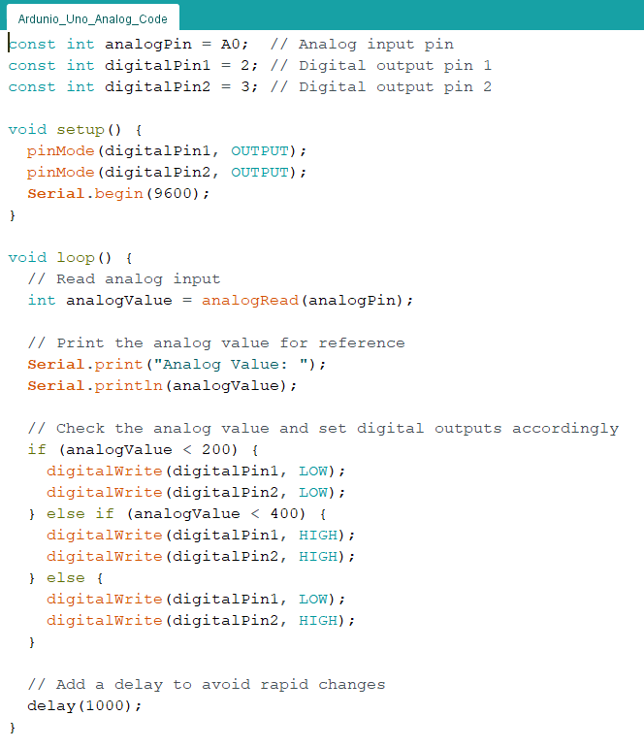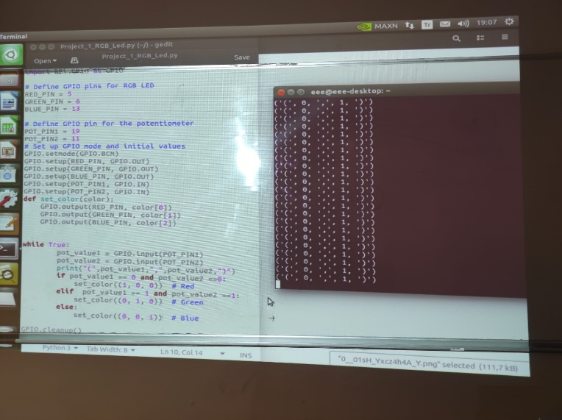

**Photo for your circuit (only 1 photo):**

